PC2232 Physics for Electrical Engineers

AY2013-14 Semester 2

TERM TEST

7 March, 2014

Time Allowed: ONE hour THIRTY minutes

INSTRUCTIONS

1. This is a closed book test.

2. This paper contains 20 multiple choice questions and 18 printed pages.

3. Each of the questions or incomplete statements is followed by five suggested answers or completions. Select the one that is best in each case and then shade the corresponding bubble on the answer sheet.

4. Only the answer sheet will be collected at the end of the test. Answers written anywhere else will not be marked.

5. Use 2B pencil only. Using any other type of pencil or pen may result in answers unrecognizable by the machine.

6. Answer all questions. Marks will NOT be deducted for wrong answers.

7. Some formulae are given in pages 15-18. Not all the formulae will be needed in the test.

8. You may not leave the test venue during the first thirty minutes and the last fifteen minutes of the test.

- An electromagnetic wave with frequency 6.50 x 10¹⁴ Hz propagates with a speed of 2.00x10⁸ m/s in a certain piece of glass. Find

 | The wavelength of the wave in the glass. | The index of refraction n of the glass for an electromagnetic wave with this frequency. | The dielectric constant for glass at this frequency, assuming that the relative permeability is unity.
(A) | 3.81 x 10⁻⁷ m | 1.38 | 1.91
(B) | 3.18 x 10⁻⁷ m | 1.45 | 2.10
(C) | 3.12 x 10⁻⁷ m | 1.48 | 2.18
(D) | 3.08 x 10⁻⁷ m | 1.50 | 2.25
(E) | 2.97 x 10⁻⁷ m | 1.55 | 2.41

Answer D

- Which of the following statements are true?

(I) Refractive index n of a piece of glass is independent of the wavelength of light.
(II) When natural (unpolarized) light passes through a polarizer, the transmitted intensity is exactly half that of incident light.
(III) If natural light is incident onto a reflecting surface at the polarizing angle, the reflected light is 100% polarized perpendicular to the plane of incidence.
(IV) According to Rayleigh scattering: light of lower wavelength are more effectively scattered by air molecules.
(V) When light goes from a medium with lower n to one with higher n, there is a maximum angle of incidence θ_{crit} beyond which no light will emerge in the second medium and light is totally reflected at the surface.

      - (I) and (II)
      - (I) and (IV)
      - (II) and (III)
      - (II), (III) and (V)
      - (II), (III) and (IV)

Answer E

- Given that the total energy radiated by the Sun every second is P = 3.77 x 10²⁶ W. What is the intensity of the solar radiation reaching Mars? (Distance from Mars to Sun = 2.28 x 10¹¹ m.)

- 1.33 x 10³ W/m²
- 6.67 x 10² W/m²
- 5.77 x 10² W/m²
- 4.45 x 10² W/m²
- 2.89 x 10² W/m²

Answer C

- The following diagram shows a beam of light propagating towards an air-glass interface at normal incidence, what is the percentage of the original light intensity that is reflected?

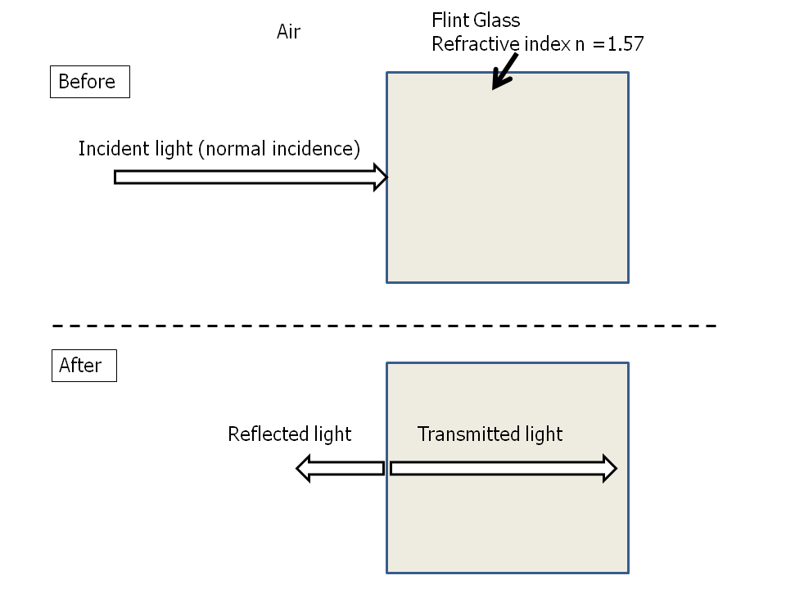

  - 4.00%
  - 4.92%
  - 6.57%
  - 20.00%
  - 22.18%

Answer B

- A laser beam is directed towards a beaker that contains a slab of glass that is submerged in water as shown. Calculate the horizontal distance d as shown.

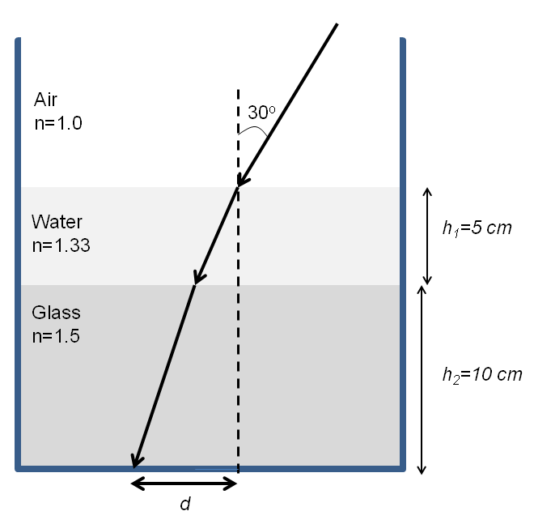

(A) 5.56 cm
(B) 3.54 cm
(C) 2.51 cm
(D) 2.03 cm
(E) 1.51 cm

Answer A

- A student set up an experiment to study the interference pattern generated by two slits with finite width as shown in the following diagram. Which of the following plots best represent the intensity pattern observed on the screen?

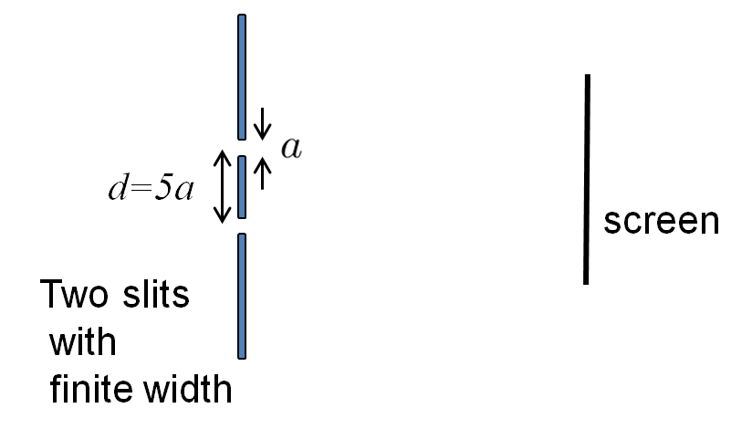

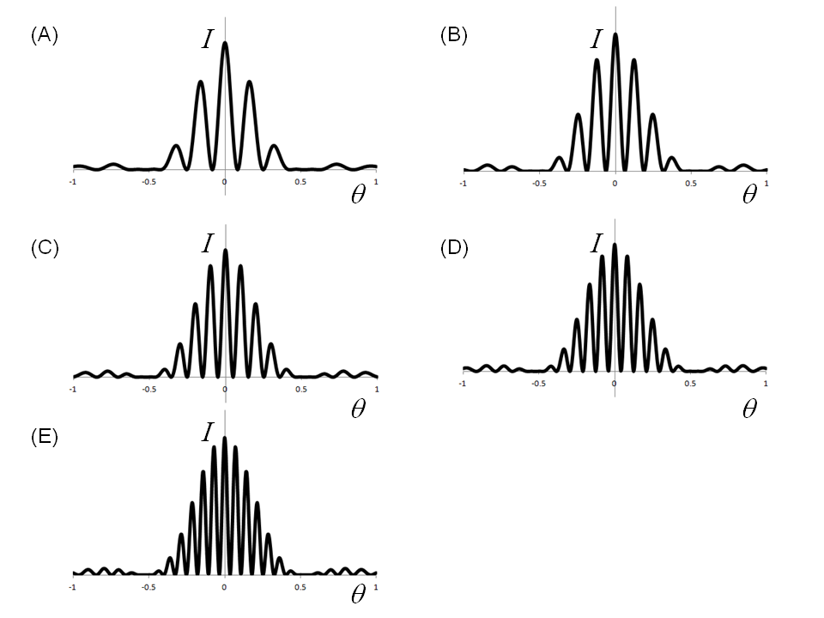

Answer C

- Consider light incident normally onto a thin film on glass as shown in the figure below. What is the condition for constructive interference for reflection? Note that t is the thickness of the film and λ is the wavelength of light in the film.
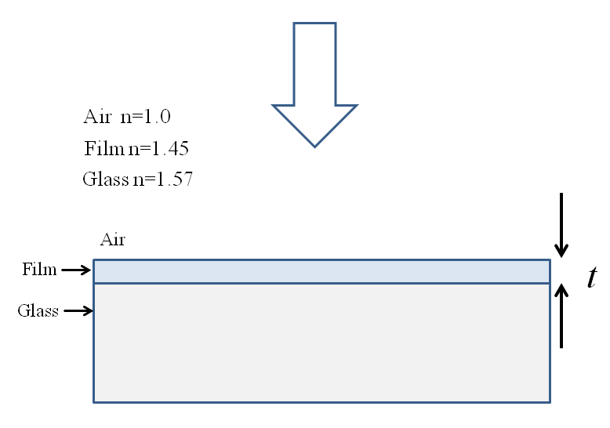

  - 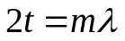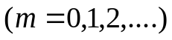
  - 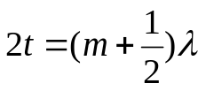
  - 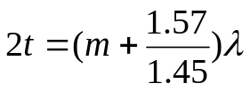
  - 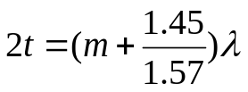
  - 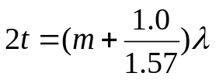
Answer A

- Red light of wavelength 632 nm is incident normally on a diffraction grating, and the second-order maximum is observed to be 39.2º from the normal. How many lines/cm are marked on the grating?

  - 5.00 x 10⁶ lines/cm
  - 2.00 x 10⁻⁶ lines/cm
  - 2.00 x 10⁴ lines/cm
  - 5.00 x 10³ lines/cm
  - 3.00 x 10³ lines/cm

Answer D

- A student performed two separate experiments on blackbody radiation using blackbody radiator at two different temperatures of T1=6000K and T2=8000K. Which of the following figures best represent be the results of blackbody radiation obtained from these experiments?
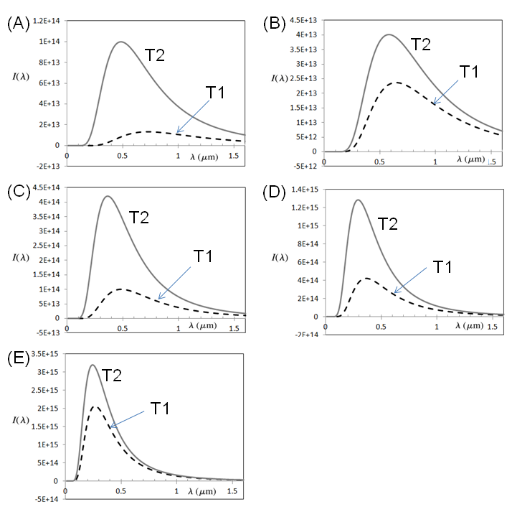

Answer C
- A student performed three separate experiments on photoelectric effect using three different light sources. The properties of the three light sources are summarized in the table below.
Light Source | Light Intensity | Wavelength of emitted light
a | I | 400 nm
b | 3I | 350 nm
c | 2I | 350 nm
Which of the following figures would be the best representation of the results of photocurrent versus applied potential obtained from these three separate experiments? The same metal surface was used throughout the experiments.

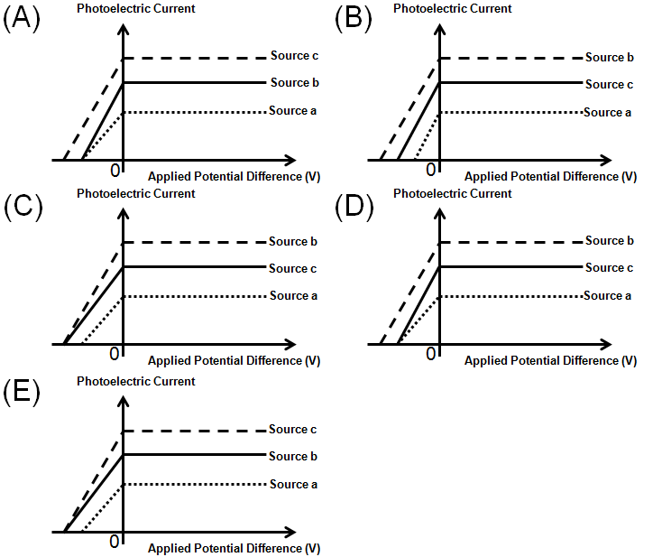

Answer C

- A student studied the photoelectric effect from two different metals by performing two separate experiments. In the first experiment, using a light source where the frequency of the light can be varied, the student obtained the following plot of stopping potential versus frequency of incident photon for the two metals. The measured value of the factor “C” as shown in the plot was found to be 0.48936. In the second experiment, using a light source emitting light with only one wavelength, the student found that the magnitude of stopping potential for photoelectrons released from Sample A is 2.4 V larger than that for Sample B. Identify Sample A and Sample B.

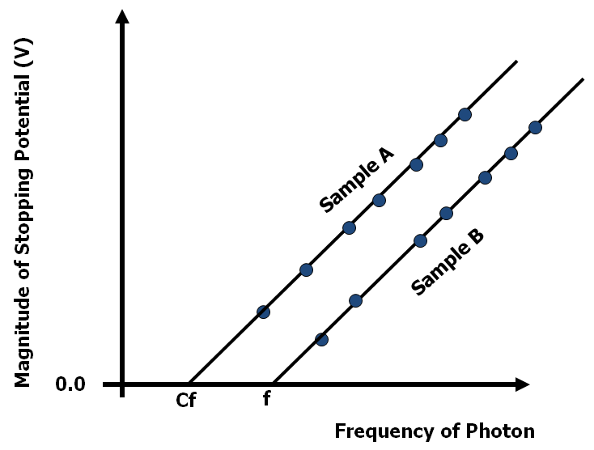

- Sample A is Sodium and Sample B is Gold.
- Sample A is Sodium and Sample B is Copper.
- Sample A is Aluminum and Sample B is Silicon.
- Sample A is Gold and Sample B is Aluminum.
- Sample A is Carbon and Sample B is Sodium.

Answer B

- During a Compton scattering experiment, an x-ray photon with a wavelength of 3 x 10⁻¹¹ m strikes a free, stationary electron, and the scattered photon departs at 90° from the initial photon direction. What is the kinetic energy of the recoiled electron?

  - 3.09 keV
  - 1.77 keV
  - 1.15 keV
  - 0.80 keV
  - 0.59 keV

Answer A

- Which of the following is not true regarding the atomic spectrum?

  - Absorption spectrum is obtained when white light shines through a gaseous cloud of the cold atoms.
  - Gas-discharge lamps are a family of artificial light sources that generate light by sending an electrical discharge through an ionized gas.
  - When all of a large group of excited Hydrogen atoms at n=5 state eventually return to the ground state, the photons detected can be categorized into 10 groups and each with a different wavelength.
  - Though an excited Neon Lamp may appear red in color, it does not mean that there is only one type of photons emitted by the excited Neon atoms.
  - Emission spectra of the hydrogen atom are the same as those from He⁺ ion.
Answer E
- In the spectrum of hydrogen, what is the ratio of the longest wavelength in the Balmer series (λ_{B}) to the longest wavelength in the Paschen series (λ_{P})? Express your answer in the ratio of λ_{B}/λ_{P}.

  - 1/2
  - 20/7
  - 5/27
  - 2
  - 7/20

Answer E

- Assuming that the one-electron ion C⁵⁺ behaves like a hydrogen atom with a nuclear charge of +6, the wavelengths of the first three lines in the Balmer series for this atom are:
- 13.2 nm, 9.7 nm, 8.7 nm
- 26.3 nm, 19.5 nm, 17.4 nm
- 18.2 nm, 13.5 nm, 12.1 nm
- 263 nm, 195 nm, 174 nm
- 183 nm, 135 nm, 121 nm

Answer C

- Which of the following statements are true?

(I) If the wavelength of a photon increases, its momentum would decrease.
(II) If the value of the Rydberg constant increases, the wavelength of the photon emitted by an excited hydrogen atom would decrease.
(III) In the experiment on photoelectric effect using the same sample, if the frequency of the light source increases, the magnitude of the stopping potential would decrease.
(IV) If the kinetic energy of a neutron decreases, its de Broglie’s wavelength would decrease.
(V) If the temperature of a blackbody object increases, the Wien’s wavelength emitted by the object would increase.

  - (I) and (II)
  - (III) and (V)
  - (I) and (IV)
  - (II) and (IV)
  - (II) and (V)

Answer (A)

- According to Bohr’s model, which of the following best represent an equation for the speed of electron (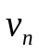) in the orbit of a hydrogen atom in a state denoted by the quantum number n? Note that h, c, m_{e} and R have the usual meaning as shown in page 15.

      - 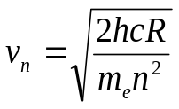

      - 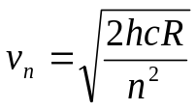

      - 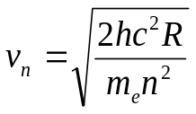

      - 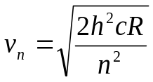

      - 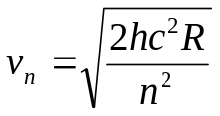

Answer A

- Combining Bohr’s model and de Broglie’s postulate, an excited state of the hydrogen atom can be represented by the following figure.

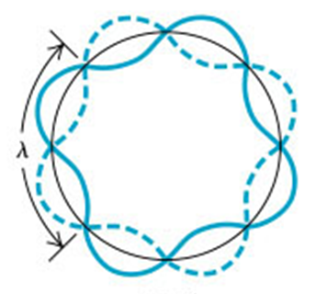

Which of the following statements are true?

(I) The radius of this Bohr orbit according to Bohr’s model is 2.12x10⁻¹⁰ m.
(II) When this atom makes a transition to a lower energy level, photon with a wavelength of 97.2 nm can be emitted.
(III) The energy of the excited atom is -0.85 eV.
(IV) According to Bohr’s model, the speed of electron in this orbit is 1.09x10⁶ m/s.

- (I) and (IV)
- (II) and (III)
- (I) and (III)
- (II) and (IV)
- (III) and (IV)

Answer B

- If we live in a universe in which the value of Planck’s constant is larger by a factor of 2, which of the following statements would be true?

(I) The de Broglie wavelength of an object would be longer by a factor of 2.
(II) The maximum kinetic energy of the photoelectron emitted during photoelectric effect would be larger by a factor of 2.
(III) The wavelength of the photons emitted from excited Hydrogen atom would be longer by a factor of 2.
(IV) The minimum of the product of the uncertainties in measuring the position and momentum of an object would be smaller by a factor of 2.
      - (I)
      - (I) and (IV)
      - (I) and (III)
      - (II) and (III)
      - (I), (III) and (IV)
Answer A
- If kinetic energy of an electron is twice the kinetic energy a proton, and the de Broglie wavelength of the proton is half the de Broglie wavelength of an alpha particle (i.e. helium nucleus with two protons and two neutrons). Which of the following represent an expression for ratio of the de Broglie wavelength of the alpha particle λ_{α} to the electron λ_{e}? Note m_{α} denotes the mass of an alpha particle and m_{e} denotes the mass of an electron. You can assume that m_{α} = 4 times the mass of proton and all the particles are non-relativistic.
  - 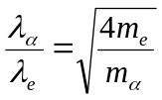

  - 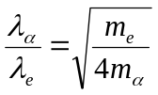

  - 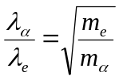

  - 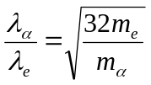

  - 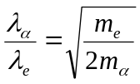
Answer D

TABLE OF INFORMATION

Speed of light in vacuum, c = 2.998 × 10⁸ m/s

Charge of electron, e = 1.602 × 10⁻¹⁹ C

Planck’s constant, h = 6.626 × 10⁻³⁴ Js

Mass of electron, me = 9.109 × 10⁻³¹ kg

Mass of proton, mp = 1.673 × 10⁻²⁷ kg

Boltzmann constant, k = 1.381 × 10⁻²³ J/K

Avogadro’s number, NA = 6.022 × 10²³ mol⁻¹

Permeability of free space, μ_{o} = 4π × 10⁻⁷ Wb/Am

Permittivity of free space, ε_{o} = 8.854 × 10⁻¹² C²/Nm²

Rydberg constant, R= 1.097 × 10⁷ m⁻¹

Stefan-Boltzmann constant, σ = 5.670 × 10⁻⁸ Wm⁻²K⁻⁴

Wien’s displacement constant, b = 2.898 × 10⁻³ mK

Bohr radius, a₀ = 5.29 × 10⁻¹¹ m

Color | Workfunction of some common materials
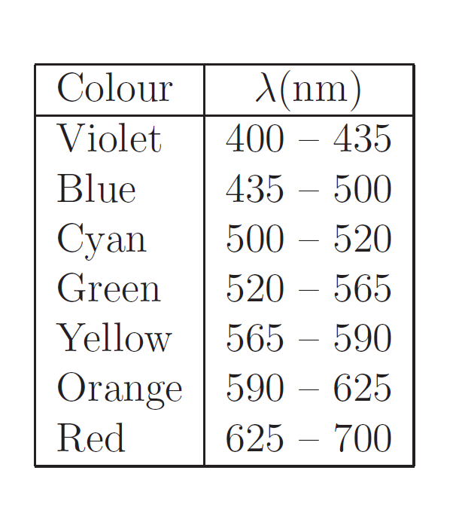 | 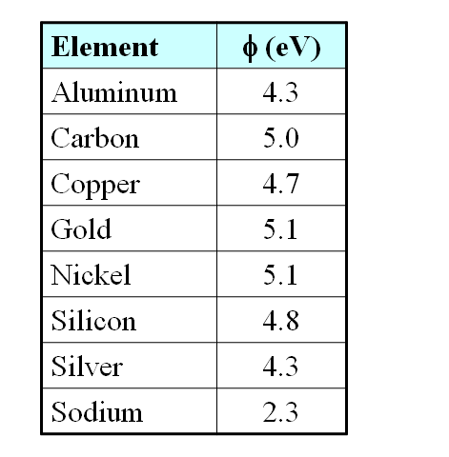

Maxwell Equation
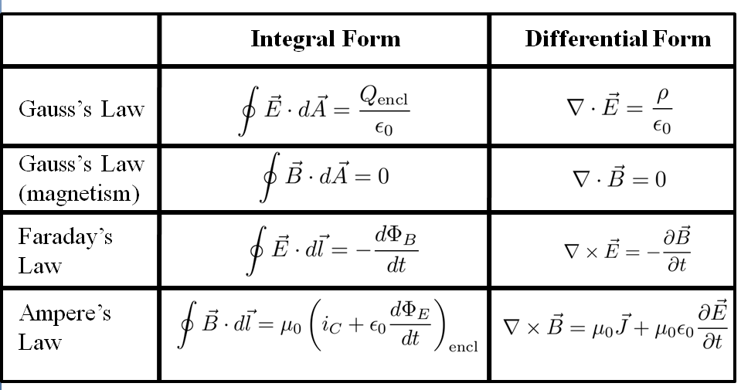
Speed of light in vacuum 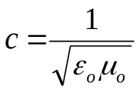
Speed of light in matter 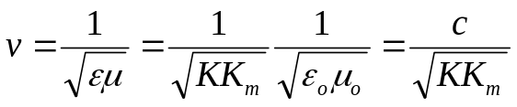
Index of refraction 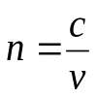
Energy Density of EM Wave 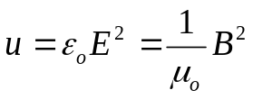
Poynting Vector 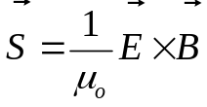
Intensity 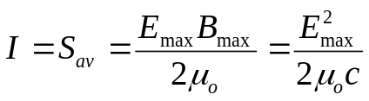
Laws of Refraction 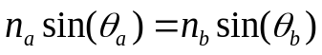
Malus’s Law 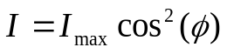 Brewster’s Law 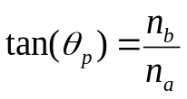

Fresnel’s Equations
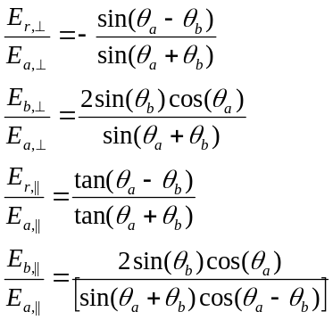
For normal incidence 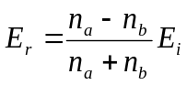
Double Slit Interference
Constructive interference 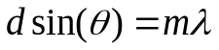 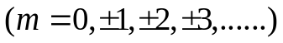
Destructive interference 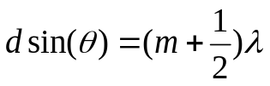
Intensity in Interference Pattern 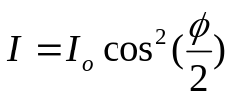
Newton’s Ring, N^{th} bright ring 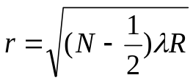, radius of dark ring 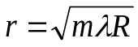
Intensity of Diffraction Pattern 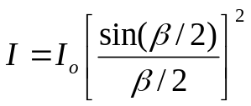 where 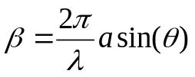
Two Slits of Finite Width
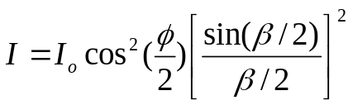 where 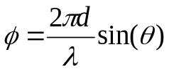 and 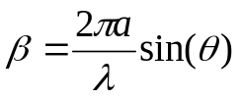
Diffraction Grating
Constructive interference 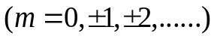
X-ray Diffraction: Bragg Condition 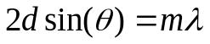 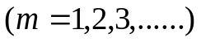
Circular Aperture First Dark Ring 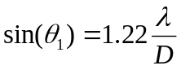
Rayleigh’s Criterion 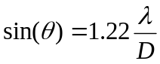
Stefan’s Law 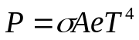 Wien’s Law 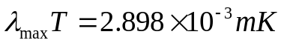
Rayleigh-Jeans Formula 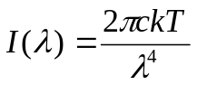 Planck’s Radiation Law 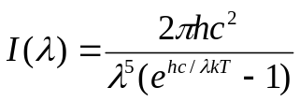
Photoelectric Effect 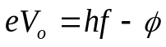 Compton Formula 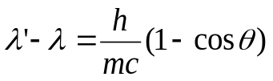
Rydberg Formula 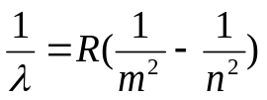 Energy of Hydrogen Atom 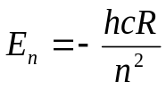
Bohr Hydrogen Atom Energy 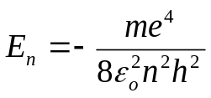 Radius 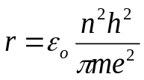
Bohr Hydrogen-like System 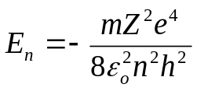 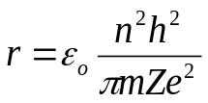
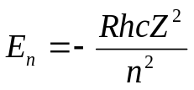 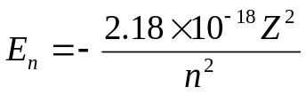Joule 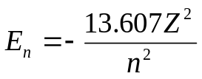eV
De Broglie’s Wavelength 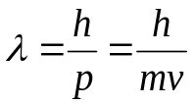
Heisenberg Uncertainty Principles 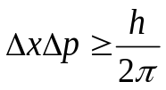 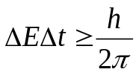
Resolution of Optical Microscope 